EXPERIMENT-02 DHILIPAN M
14/07/2026 192411038

8-QUEEN PROBLEM USING BACKTRACKING ALGORITHM
AIM:
To write a Python program to solve the 8-Queen Problem using the Backtracking algorithm.
ALGORITHM:
Step 1: Read the number of queens from the user.
Step 2: Create an empty chessboard of size N × N.
Step 3: Place a queen in the current column if it is safe.
Step 4: Move to the next column and repeat the process.
Step 5: If no safe position is available, backtrack and try another position.
Step 6: Display the final arrangement of queens if a solution exists; otherwise, display "No Solution Exists."

PROGRAM:
n=int(input("Enter the number of queens: "))
board=[[0]*n for _ in range(n)]
def safe(row,col):
for i in range(col):
if board[row][i]:
return False
i,j=row,col
while i>=0 and j>=0:
if board[i][j]:
return False
i-=1
j-=1
i,j=row,col
while i<n and j>=0:
if board[i][j]:
return False
i+=1
j-=1
return True
def solve(col):
if col==n:
return True
for i in range(n):
if safe(i,col):
board[i][col]=1
if solve(col+1):
return True
board[i][col]=0
return False
if solve(0):
print("Solution:")
for row in board:
print(*row)
else:
print("No solution exists")

OUTPUT:

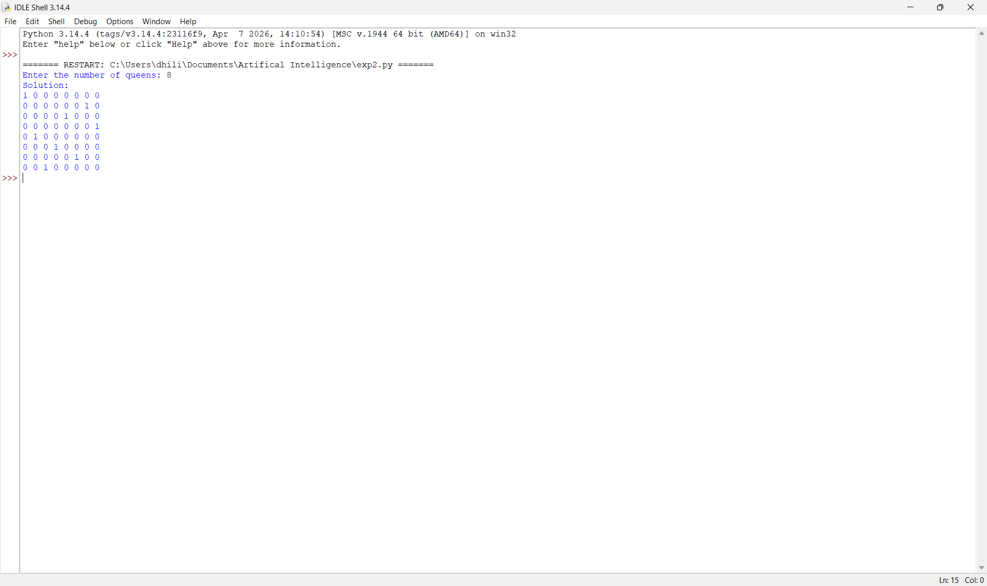

RESULT:
Thus, the Python program to solve the 8-Queen Problem using the Backtracking Algorithm was implemented successfully and the required output was obtained.

